Table of Contents
Cogito: A MongoDB-Based Document Assistant with Hybrid Search and Cited Answers 1
Abstract 2
1. Introduction 2
2. System overview 2
3. Data model 4
4. Automatic indexing with change streams 6
5. Hybrid retrieval 7
6. Analytics with aggregation pipelines 8
7. Transactions, atomicity, and the replica set 9
8. The AI components 10
9. Testing and verification 12
10. Results 13
11. Problems and how they were fixed 14
12. Limitations and future work 14
13. Conclusion 15
References 15
Appendix A: Running the project 16
Appendix B: Repository structure 16

Cogito: A MongoDB-Based Document Assistant with Hybrid Search and Cited Answers
Course project report Subject: NoSQL databases Submitted by:
S. No. | Name | Roll number
1 | Pranesh Nikhar | 2427010267
2 | Soumyajit Chatterjee | 2427010255
3 | Anmol Kaushik | 2427010576
4 | Ojas Khandelwal | 2427010381
Date: 18th October 2026

Abstract
Cogito is a document assistant based on MongoDB. Documents index themselves through change streams, questions are answered via hybrid retrieval, combining keyword search and vector search, and every answer is backed up by references to the relevant passages. The system showcases the database capabilities that make this work without any additional setup: change streams, multi-document transactions, $search, $vectorSearch, $rankFusion, and analytics with aggregation pipelines. A retrieval-augmented generation pipeline (chunking, embeddings, reranking, cited answers, LLM-judged evaluation, feedback loop, agent loop, and long-term memory) is implemented above the same stack. The system has a REST API, a web dashboard, and an MCP server, and can operate both offline or with OpenAI, Gemini, OpenRouter, or Ollama as the model provider.

1. Introduction
Cogito is a web-based tool which stores documents and answers queries about the contents of these documents. A user uploads a document which may come in the form of a PDF file, text file, a contract or even a webpage. The system analyzes the text in the document, splits it into passages and stores the passages along with numeric vector corresponding to the meaning of the passage. The system then retrieves the most relevant passages and creates an answer for the question asked by a user in natural language.
This project was motivated by one question: How much of a document processing system can fit into a single database? In this implementation, all the operations - from storing the documents and their vectors to running the keyword search, running the semantic search, computing the dashboard analytics to triggering the indexing jobs upon arrival of a new document, all these tasks are performed by MongoDB.

2. System overview
The application has four main behaviours.
- Automatic indexing. Inserting a document marks it as pending. A background worker picks it up, extracts the text, splits it, embeds each part, and stores the chunks. The worker listens to a change stream, so nothing has to be scheduled or re-run by hand.
- Hybrid retrieval. A question matches stored passages in two ways, by exact words and by meaning. The two ranked lists are merged into one ranking with Reciprocal Rank Fusion [4][9].
- Cited answers. A language model receives the retrieved passages with a strict instruction: every claim must trace back to a passage, and the response must list its citations. If no model provider is configured, a built-in local generator produces the same response shape, so the whole pipeline still runs offline.
- Three interfaces. The same assistant is reachable through a REST API (FastAPI), a web dashboard (Next.js), and a Model Context Protocol (MCP) server [12], which lets AI clients such as Claude Desktop or Cursor query the knowledge base as a tool.
The screenshot below shows the web chat answering a question with a grounded, cited response.
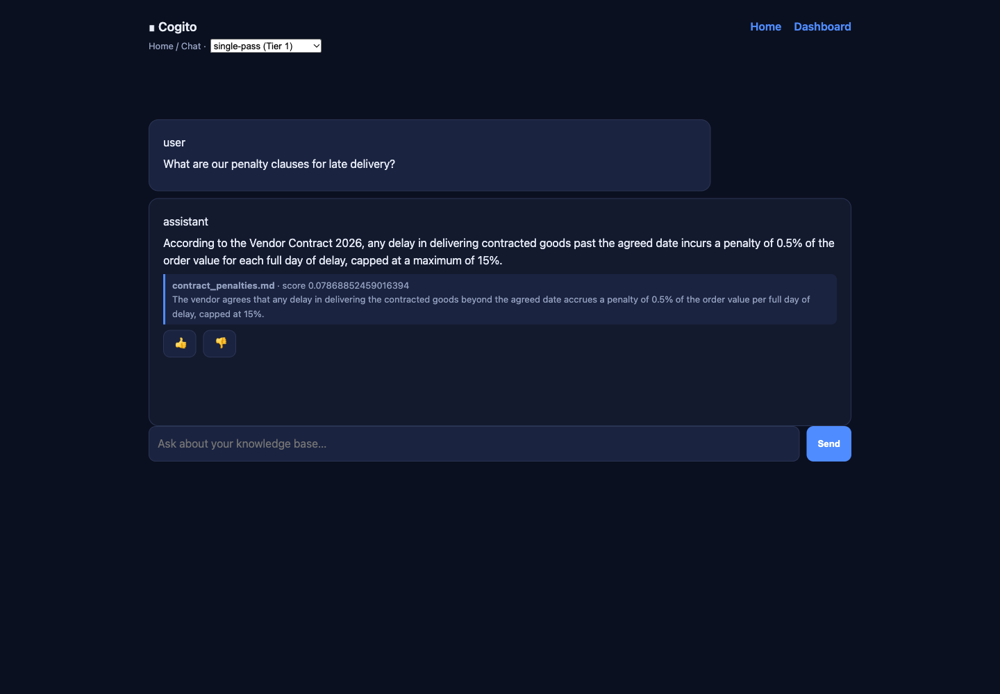
Figure 1: The chat interface returning a cited answer generated from the retrieved passages.

2.1 API surface
The backend exposes the following HTTP routes (admin routes require the X-Admin-Token header):
Method and path | Purpose
GET /health, GET /capabilities | service health and the active search/LLM mode
POST /ingest, POST /ingest/raw | add a document (file upload or raw text)
GET /ingest/documents | list ingested documents and their status
POST /search, POST /search/multi | ranked passages, single or multi-query
POST /ask, POST /ask/multi, POST /ask/agent | grounded answers, direct or through the agent loop
POST /chat, GET /chat/conversations | chat with history and memory recall
POST /memories, GET /memories, POST /memories/recall | long-term facts
POST /feedback | thumbs up or down on an answer
GET /eval | LLM-judge scores per answer
GET /analytics/overview, /histogram, /queries, /unanswered, /freshness | dashboard aggregations
POST /webhooks/ingest, POST /analytics/rollup | automation and reporting hooks

3. Data model
The system uses seven collections in one MongoDB database.
Collection | Purpose | Key fields
documents | source files and metadata | _id, path, title, type, hash, status, raw, summary, keywords, chunk_count
chunks | text passages and vectors | _id, document_id, text, embedding, page, order, token_count, title, boost
conversations | chat history | _id, user_id, messages[], created_at
memories | long-term facts | _id, user_id, fact, embedding, importance, updated_at
query_logs | one record per question | _id, question, chunks_returned, chunk_ids[], latency_ms, answer_id, ts
eval_results | judge scores | _id, answer_id, faithfulness, relevance, judge, ts
feedback | user ratings | _id, answer_id, rating, comment, ts

3.1 The unit of storage
The key design decision is the unit of storage. The natural unit of work in a retrieval system is a chunk: a passage, its vector, and its metadata. In a relational schema those would be a row, another row (or a large column), and a join across tables. Here they form one JSON document, which is exactly the shape the retrieval code needs to read [15]. A stored chunk looks like this:
{
"_id": "c392cfe9-...",
"document_id": "82f9cb6d-...",
"text": "4.1 Late Delivery. The vendor agrees that any delay ...",
"embedding": [0.013, -0.041, 0.008, "..."],
"page": 1,
"order": 3,
"token_count": 141,
"title": "contract_penalties.md",
"mime": "text/markdown",
"boost": 1.0,
"created_at": 1792312802.17
}

3.2 Flexible schema in practice

Optional elements show up only if they have any relevance. A chunk will be having page only if it is paginated, summary and keywords will show up only when there is some enrichment of the document, and the boost value will start with 1.0 and will vary according to rating given by users for the answers. In a relational database schema, nullable columns or additional tables will be required in each of these cases. The raw bytes of the file are also stored in the document itself as BSON binary.3.3 Indexes
Index | Field | Used for
Text index | chunks.text | lexical search in fallback mode ($text)
Search index | chunks.text (MongoDB Search) | lexical search in full mode ($search)
Vector index | chunks.embedding, HNSW, cosine, scalar quantization | semantic search ($vectorSearch)
Single field | documents.status | finding pending documents
Single field | chunks.document_id | fetching the chunks of one document
Compound | documents on (path, hash) | duplicate detection at ingest
Compound | memories on (user_id, updated_at) | per-user recall, newest first
Single field | query_logs.ts | analytics over time

4. Automatic indexing with change streams
Change streams are the feature that shaped the whole design [1]. A change stream is a database cursor that emits events whenever documents change. The worker opens a stream on the documents collection and waits. When a document with status pending appears, the worker extracts the text, chunks it, embeds each chunk, stores everything, and flips the status to indexed.
The full sequence for one upload is:
- POST /ingest writes the document with status: "pending" and the raw bytes.
- The change stream fires an insert event (with full_document: "updateLookup").
- The worker extracts text (pypdf, python-docx, or plain decode depending on the file type).
- The text is split into overlapping passages with a recursive splitter.
- Each passage is embedded by the configured provider (Gemini, OpenAI, OpenRouter, Ollama, or the built-in local embedder).
- The chunks are written and the document is flipped to indexed inside one transaction.
Two details matter for reliability. First, the worker stores the stream’s resume token in Redis after each event, so a restart resumes from the last processed event instead of losing whatever arrived in between. Second, on startup the worker backfills any documents still marked pending, which covers the case where the API accepted a document while the worker was down.
We measured the drop-to-indexed latency in the analytics endpoint. With the local embedder, a document became queryable about 0.26 seconds after insertion, and about 6 milliseconds when models were warm. With the Gemini embedding API the same step takes 1.6 to 4.4 seconds per document, which is the network round-trip to the provider and is visible in the dashboard’s freshness panel.
So, cogito is a knowledge storage where it indexes itself. Drop your documents, a MongoDB change stream notices them and automatically chunks , embeds, and stores them. You can ask questions in plain English and it will answer those by looking at the database where you stored the documents.

5. Hybrid retrieval
Retrieval combines two different signals. Keyword search matches literal words and clause numbers. Semantic search matches meaning, so a question about “late delivery fees” can match a passage titled “vendor obligations”. Each signal alone has a known failure mode: keyword search misses paraphrase, and vector search is unreliable on exact identifiers.

5.1 The two modes
Condition | Path | Operators
MongoDB Search (mongot) available | _full_hybrid | $search + $vectorSearch combined by $rankFusion
Plain mongod (no search engine) | _fallback_hybrid | $text + cosine similarity combined by an in-code RRF
Both paths return the same fields (_id, text, document_id, title, page, score), so the rest of the system does not know which one ran. A startup probe decides the mode, and the result is cached in db.search_mode_sync() for the hot path.

5.2 The native pipeline
In full mode the whole retrieval is a single aggregation. This is the pipeline the code sends (simplified):
[
{ $rankFusion: {
input: {
pipelines: {
search: [ { $search: { index: "cogito_text",
text: { query: question, path: "text" } } } ],
vector: [ { $vectorSearch: { index: "cogito_vector",
path: "embedding",
queryVector: queryEmbedding,
numCandidates: 100,
limit: 100 } } ]
}
}
} },
{ $limit: k },
{ $project: { _id: 1, text: 1, document_id: 1, title: 1, page: 1,
score: { $meta: "score" } } }
]
$rankFusion executes both pipelines, de-duplicates the results, and scores every document with the Reciprocal Rank Fusion formula, where each pipeline contributes a weighted 1/(60 + rank) term. The constant 60 is chosen by MongoDB [4]; the technique itself comes from Cormack et al. [9]. The fused score is surfaced through the $meta: "score" expression, which took one debugging round to get right (section 11, problem 3).

5.3 The fallback pipeline

In the absence of MongoDB Search support, the lexical branch executes a search on top of a $text index, while the semantic branch calculates cosine similarities between the vectors in Python. The two lists are combined through _rrf_fuse, which uses the exact same reciprocal rank formula in roughly ten lines of code. It is not as fast as the native approach for big collections, but yields the same ordering results and remains usable everywhere.

The search fetches 5 chunks by default, whereas the vector branch takes into account 100 chunks. Such an excess of requests is based on the recommendations from the $vectorSearch docs, which suggest making at least 20 times more requests than the result limit [3].5.4 Reranking and query expansion
Retrieved candidates pass through a reranker. When the sentence-transformers library is installed, a cross-encoder model (ms-marco-MiniLM-L-6-v2 [11]) re-scores every candidate against the question; without it, a lighter lexical boost promotes chunks that share distinctive terms with the question. Multi-query search expands the question into several rewritings, retrieves for each, and fuses the results; offline it uses a deterministic keyword expansion, and with a model key it asks the model for real rewritings.

6. Analytics with aggregation pipelines
The dashboard is computed entirely with aggregation pipelines over query_logs, eval_results, and feedback. The overview endpoint runs one $facet pass that computes several metrics at once:
{ $facet: {
totals: [ { $count: "n" } ],
unanswered: [ { $match: { chunks_returned: 0 } }, { $count: "n" } ],
latency: [ { $group: { _id: null,
avg: { $avg: "$latency_ms" },
max: { $max: "$latency_ms" } } } ],
by_day: [ { $group: { _id: { $dateToString: {
format: "%Y-%m-%d",
date: { $toDate: { $multiply: ["$ts", 1000] } } } },
count: { $sum: 1 } } },
{ $sort: { _id: 1 } } ]
} }
The other dashboard panels use $bucketAuto (an eight-bucket latency histogram) and $group with $sort and $limit (the most frequent questions). $facet is worth noting because it returns each sub-pipeline as an array, a detail that produced a real bug during development (section 11, problem 1).
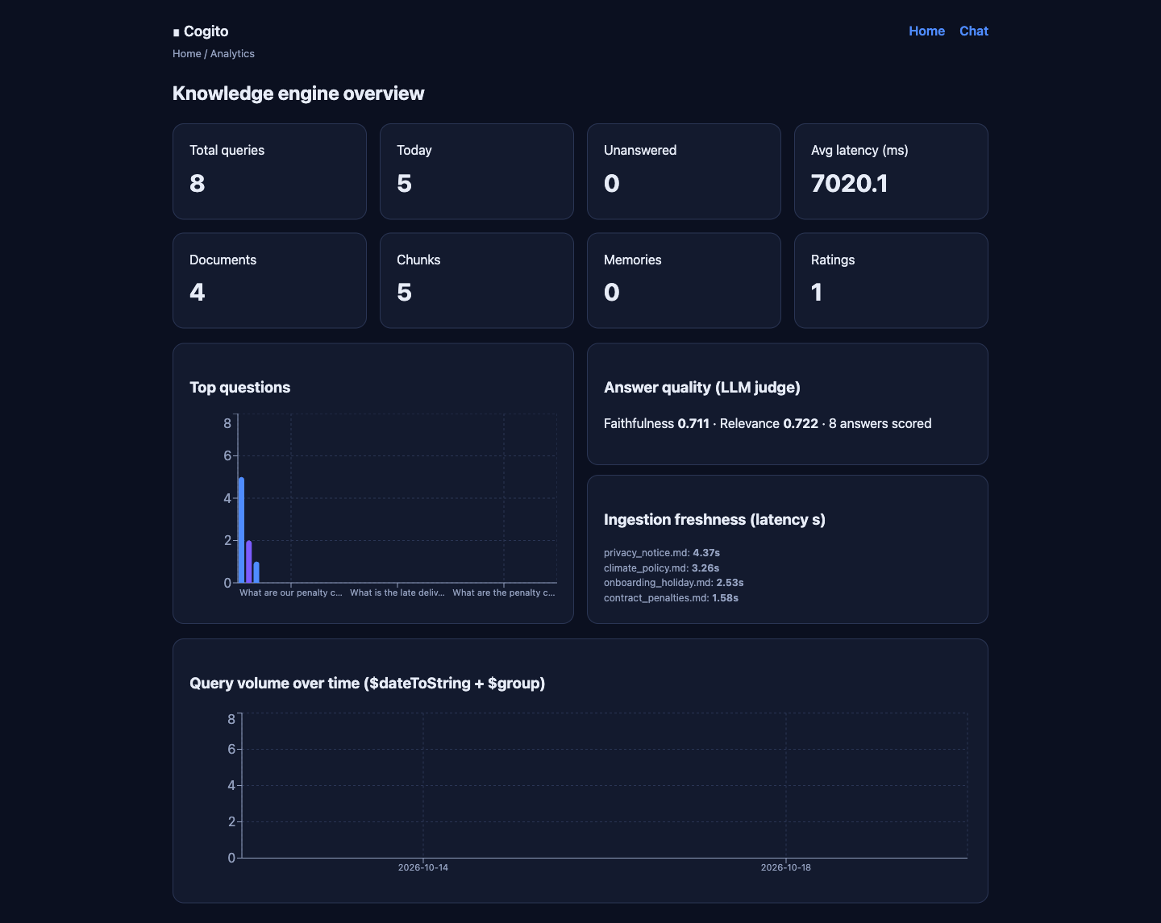
Figure 2: The analytics dashboard, computed from query logs with aggregation pipelines.
The screenshot above shows the dashboard after four documents were ingested and several questions were asked: totals per collection, the average end-to-end latency with the Gemini provider (7,423 ms per answer, dominated by the two model calls), the ingestion freshness per document, the LLM-judge scores (faithfulness and relevance), and the two charts.

7. Transactions, atomicity, and the replica set
Re-indexing a document replaces its chunks. If the delete succeeded and the insert failed, the document would look indexed while its content was missing. The ingestion function therefore performs the delete, the insert, and the status update inside one multi-document transaction [6]:
async with await client.start_session() as session, session.start_transaction():
await chunks.delete_many({"document_id": doc_id}, session=session)
if to_insert:
await chunks.insert_many(to_insert, session=session)
await documents.update_one({"_id": doc_id}, status_update, session=session)
Writing the await correctly took two attempts. The first version omitted it, the transaction never actually started, and the code silently used the three-write fallback; section 11 explains how the mistake was found.
Change streams and transactions both require a replica set [8]. The Docker setup promotes a single node into a one-member replica set (rs0) during bootstrap, so both features work with one container and no extra machine.

8. The AI components
AI appears at several stages of the pipeline. Every stage is pluggable: it runs fully offline with built-in local models, and upgrades automatically when a provider key is configured.

8.1 Embeddings
The first AI step converts text into vectors. The project implements five embedding providers behind one interface:
Provider | Model (default) | Dimension | Key needed
Local (built-in) | hashed word n-grams | 384 | no
Gemini | gemini-embedding-001 | 3072, stored at 768 | yes
OpenAI | text-embedding-3-small | 1536, stored at EMBEDDING_DIM | yes
OpenRouter | any served embedding model | as configured | yes
Ollama | nomic-embed-text | as configured | local server
The local embedder hashes word unigrams and trigrams into a fixed-size vector and normalizes it, which keeps the pipeline runnable with no accounts. Every provider’s output passes through fit(), which trims or pads the vector to EMBEDDING_DIM and re-normalizes it. For Gemini this matters: the model returns 3072 dimensions by default, the project stores 768 (a recommended size for this model), and fit() performs exactly the truncation and renormalization the documentation requires for that case. The query path applies the same normalization, without which the query vector and the index dimensions disagree; that mismatch was one of the bugs found during development.

8.2 Chunking
Documents are split with a recursive character splitter with overlap. The parameters are:
Parameter | Value
Chunk size | 800 characters (500 for contract documents)
Overlap | 120 characters
Separators | paragraph, line, sentence, semicolon, word, character
PDF extraction inserts a page marker between pages, so a citation can point at a page number. The extractor also handles DOCX, HTML, CSV, JSON, plain text, and images through OCR when Tesseract is available.

8.3 Document enrichment

The document is tagged with a summary and keywords after it has been processed. Extractive summarization algorithm assigns scores to sentences according to the frequency of occurrence of non-stop words in the sentences. Top-scoring sentences are used as a summary. An LLM produces an abstractive summary if a model key is

provided.8.4 Grounded answers
The retrieved chunks are sent to the model with a system prompt that requires a JSON response with the answer and its citations, and that instructs the model to say so when the context does not contain the answer [10]. The expected contract is:
{
"answer": "Under Section 4.1, late delivery accrues a 0.5% penalty per day, capped at 15%.",
"citations": [
{ "document_id": "82f9cb6d-...", "title": "contract_penalties.md",
"excerpt": "4.1 Late Delivery. The vendor agrees ...", "score": 0.079 }
]
}
Provider calls run through a single background event loop. The API handlers and the ingest worker are asyncio-based, so a blocking provider call would stall the server; routing every call to one long-lived loop thread gave a synchronous facade without that problem. This design is shared by OpenRouter, OpenAI, Gemini, and Ollama.

8.5 Evaluation
Every answer is scored on two axes. Faithfulness asks whether each claim is supported by a retrieved chunk (a hallucination guard). Relevance asks whether the answer actually addresses the question. With a model configured, the model is the judge; offline, a deterministic heuristic compares the answer’s terms against the question and the context. Scores are stored in eval_results and charted on the dashboard, so a change in retrieval or prompt quality is visible over time.

8.6 Feedback loop
When a user rates an answer thumbs up or thumbs down, the chunks that produced it receive a boost adjustment: +0.5 for a helpful rating and -0.25 for a poor one, clamped between 0.25 and 4.0. Retrieval applies the multiplier to the fusion score before reranking, so the ranking changes as ratings accumulate. This is the simplest possible learning-to-rank loop, and it is fully inspectable: the boost is a plain field on the chunk.

8.7 Agent loop and long-term memory
The agent endpoint runs a LangGraph StateGraph [13] with three nodes:
- retrieve: run hybrid search with a larger budget (40 candidates).
- should_refine: compute confidence as the average score of the top three chunks. If confidence is below the threshold and fewer chunks came back than the top-k setting, refine the query by adding distinctive terms from the best chunk and retrieve again, bounded by AGENT_MAX_ITERATIONS (3).
- generate: produce the grounded, cited answer.
The memory feature stores extracted facts in the memories collection with their embeddings. Recall embeds the query and computes cosine similarity against a user’s memories, returning the closest few, which are injected into later prompts. This is the “agent memory” pattern implemented directly on the same database.

9. Testing and verification
The repository includes automated tests and a small CI pipeline.
Area | What is tested
Chunking | overlap behaviour, stable content hashes, page tracking for PDFs
Embeddings | local embedder dimension and normalization, fit() behaviour, output dimension of the public API
Providers | Gemini provider wiring through the factories
Concurrency | the sync-over-async runner from inside and outside a running event loop
Local LLM | cited answer shape, empty-context behaviour
Evaluation | heuristic judge ranges
Retrieval | lexical rerank promotes the passage containing the query terms
Expansion | deterministic multi-query expansion produces unique variants
Extraction | HTML and DOCX parsing, graceful degradation on unknown binary input
The commands are:
cd src/backend
pip install -e ".[dev]"
pytest tests/ -q # 17 tests
ruff check app # linter
In addition to the unit tests, tests/test_mcp_client.py is a standalone smoke script that starts the MCP server over stdio and calls its tools, and scripts/seed.py inserts four sample documents for a manual run. Continuous integration runs the linter and the test suite on every push.

10. Results
The system was verified end to end on 18 October 2026, running the Docker stack on a laptop with the Gemini provider configured for both chat and embeddings.
Measurement | Result
Automated tests | 17 passing, linter clean
Ingestion, local embedder | 0.26 s first run, 6 ms warm
Ingestion, Gemini embeddings | 1.6 to 4.4 s per document (network bound)
Answer latency, Gemini chat and judge | about 7.4 s average end to end
Retrieval | hybrid mode active ($search + $vectorSearch + $rankFusion)
Answer quality | faithfulness and relevance scored per answer by the LLM judge
Interfaces | REST API, dashboard, and 7 MCP tools verified
Both screenshots in this report were captured from the running system: the chat interface answering a question about the penalty clauses (Figure 1) and the dashboard after ingestion (Figure 2). The dashboard numbers correspond to the four seeded documents (climate policy, privacy notice, onboarding holiday policy, and vendor contract), five chunks, and the questions asked during verification.
With the offline providers the same pipeline runs with template answers and hashed embeddings; a provider key changes answer quality, not the structure of the system.

11. Problems and how they were fixed
- The analytics endpoint crashed as soon as real data existed. $facet returns each sub-pipeline’s output as an array, and the code treated the result as a single object. The endpoint returned 500 only after query_logs had rows, which made the cause non-obvious. The fix unwraps the first element of each array.
- Re-indexing never used a transaction. Motor returns a future from client.start_session(). The first version used it directly in an async with, so the transaction never started and the code fell through to the three-write fallback without raising anything. The fix was one missing await.
- The fused score was missing from results. $rankFusion attaches its score in a metadata field, and the projection read the wrong path, so every result carried a zero score. Projecting with {"$meta": "score"} fixed it.
- The evaluation endpoint returned a serialization error. MongoDB identifiers are ObjectId objects and are not JSON serializable, so GET /eval failed as soon as it returned stored documents. The response now converts identifiers to strings.
- The MCP smoke test failed. The MCP SDK’s stdio client forwards only a whitelist of environment variables to the server process, so the MongoDB URI never arrived and the server could not connect. The test now passes its environment explicitly.
A sixth issue appeared during the final provider switch and is worth mentioning because it combined three causes: the containers were still running an image built before the new provider code existed, the old worker consumed the change stream during the container swap and re-embedded documents with the previous provider, and, once the new code was live, the query path sent 3072-dimension vectors to an index built for 768. The first two were deployment sequencing; the third was a genuine code gap and now has a unit test.
[FILL IN - your own words: pick two of the problems above and describe what you observed first, what you suspected, and how you confirmed the fix. Two or three sentences each.]

12. Limitations and future work
- Authentication is a single shared admin token for write routes. The data model already carries user_id fields, but there is no real login or per-user isolation yet.
- Offline mode answers with a template generator and hashed embeddings. It demonstrates the pipeline; meaningful answer quality needs an API key.
- The reranker is optional because sentence-transformers is not a required dependency, and the lexical fallback is weaker than the cross-encoder.
- The deployment is a single MongoDB container intended for a demonstration. A production system would separate services and size the cluster properly.
- The MCP integration is outbound only. A next step would be connecting to MongoDB’s official MCP server so the agent can compose its own aggregations instead of calling fixed tools.

13. Conclusion
The project Cogito demonstrated to us what can be done with a document database when the features of such a system are put to use in tandem. Change streams made it unnecessary to have an indexing pipeline, multi-document transactions ensured safe re-indexing, while the aggregation framework created the dashboard without the need for a dedicated reporting tool. Having been accustomed to relational databases before, the most evident distinction between these two types of systems is, certainly, the data model: treating the chunk, its vector, and its metadata as a single document made all the pipeline steps easy, while a flexible schema allowed having optional fields only where needed. Our advice to other students would be to start testing with real data on day one, as all bugs discovered by us, ranging from facet arrays to dimension mismatch, appeared only with actual documents and model provider present.

References
[1] MongoDB. Change Streams. https://www.mongodb.com/docs/manual/changeStreams/
[2] MongoDB. $search aggregation stage (MongoDB Search). https://www.mongodb.com/docs/search/query/aggregation-stages/search/
[3] MongoDB. Run Vector Search ANN and ENN Queries ($vectorSearch). https://www.mongodb.com/docs/vector-search/query/aggregation-stages/vector-search-stage/
[4] MongoDB. $rankFusion aggregation stage. https://www.mongodb.com/docs/manual/reference/operator/aggregation/rankFusion/
[5] MongoDB. Aggregation Pipeline. https://www.mongodb.com/docs/manual/core/aggregation-pipeline/
[6] MongoDB. Transactions. https://www.mongodb.com/docs/manual/core/transactions/
[7] MongoDB. Indexes. https://www.mongodb.com/docs/manual/indexes/
[8] MongoDB. Replication. https://www.mongodb.com/docs/manual/replication/
[9] G. V. Cormack, C. L. A. Clarke, and S. Buettcher. Reciprocal Rank Fusion Outperforms Condorcet and Individual Rank Learning Methods. SIGIR 2009. https://plg.uwaterloo.ca/~gvcormac/cormacksigir09-rrf.pdf
[10] P. Lewis et al. Retrieval-Augmented Generation for Knowledge-Intensive NLP Tasks. NeurIPS 2020. https://arxiv.org/abs/2005.11401
[11] Sentence-Transformers. cross-encoder/ms-marco-MiniLM-L-6-v2 model card. https://huggingface.co/cross-encoder/ms-marco-MiniLM-L-6-v2
[12] Model Context Protocol. Specification and documentation. https://modelcontextprotocol.io/
[13] LangChain. LangGraph overview. https://docs.langchain.com/oss/python/langgraph/overview
[14] Google. Gemini API OpenAI compatibility. https://ai.google.dev/gemini-api/docs/openai
[15] MongoDB. Data Modeling. https://www.mongodb.com/docs/manual/data-modeling/

Appendix A: Running the project
# 1. start the stack (MongoDB with Search, backend, worker, Redis, Postgres)
cp .env.example .env
docker compose up -d --build
# 2. seed four sample documents (the change stream indexes them)
docker exec cogito-backend python -m app.scripts.seed
# 3. ask a question
curl -s -XPOST localhost:8000/ask -H 'Content-Type: application/json' \
-d '{"question":"What are the penalty clauses for late delivery?"}'
# 4. web interfaces
open http://localhost:8000/docs # API documentation
open http://localhost:3000/chat # chat
open http://localhost:3000/dashboard # analytics

Appendix B: Repository structure
Cogito/
├── docker-compose.yml full local stack
├── docker/ replica-set bootstrap and Postgres schema
├── src/backend/
│ ├── app/ FastAPI app, ingestion worker, core modules
│ │ ├── core/ retrieval, llm, agent, evaluator, memory, feedback
│ │ ├── routers/ ingest, search, chat, memory, analytics, health
│ │ └── scripts/ ensure_indexes, seed
│ └── tests/ unit tests and the MCP smoke script
├── src/mcp_cogito/server.py MCP tools
├── web/ Next.js chat page and dashboard
└── docs/ proposal, report, feature map

